**Vehicle Standby Limitation**

***Work-flow to Use Vehicle Standby Limitation***

The Vehicle Standby Limitation preference is accessed through **Load Template** and only one instance of it is permitted.

***Preference Overview***

The Vehicle Standby Limitation preference sets a vehicle standby time range for which vehicles may not be in use. For example, if we schedule a vehicle work period of 24 hours with a standby limitation of 6 to 8 hours, then the vehicles should work between

24 - 8 = 16 to 24 - 6 = 18 hours per 24 hour work period.

The time range is just a minimum to a maximum time with a possible penalty for a standby outside the range. It is a vehicle load balancing device.

***Templates Available from Optibus***

***Vehicle standby limitation***

**Purpose:**

Sets the standby period with an optional penalty for violation.

**Prerequisites:** None.

**Opening Dialog:**

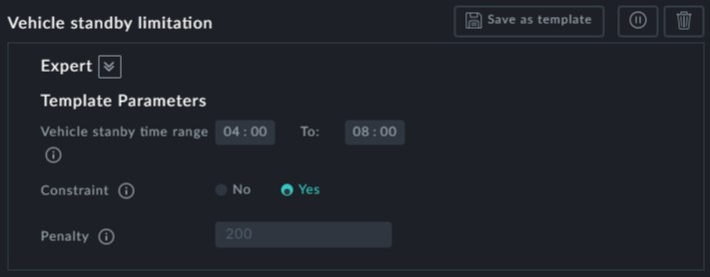

**Points to note:**

**Vehicle standby time range**: The **Vehicle standby time range** is a preferred min- imum stanby time to a preferred maximum standby time.



**Constraint**: The upper limit of the standby time range can be made a constraint by



setting **Constraint** to Yes.

**Penalty**: The penalty is imposed when the standby time is less than the lower limit or higher than the upper limit. In our example in the Overview, a penalty would be imposed if the vehicle worked less than 16 or more than 18 hours in the 24 hour work period.



Only one instance of this template may be used

